Important: Please view the first three minutes of this very helpful video that demonstrates what it looks like when you enter a conference room. https://youtu.be/uYYnryIM0Uw

Join a Conference
- Click on “Conferences” in left navigation menu.
- Click on “Join.”
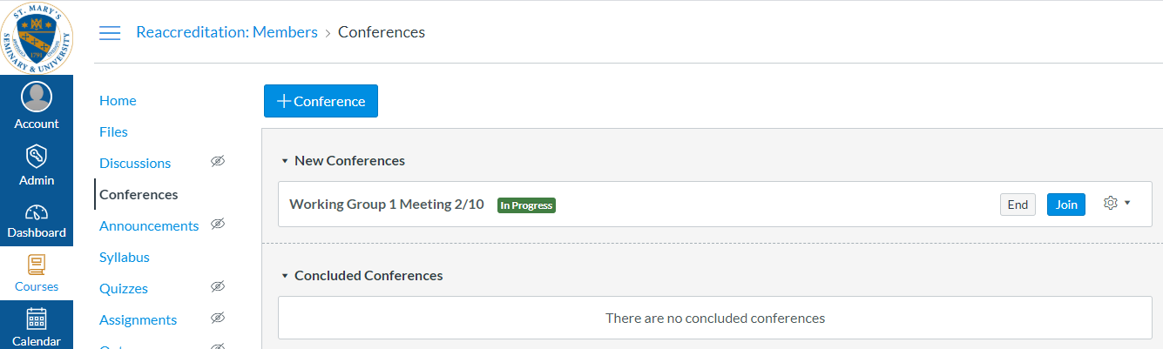
- Join the audio by microphone.
- Allow access to your microphone (there is usually a pop-up window on your screen).

- Perform the echo test by speaking a few words.

- a. Mute your microphone until you are ready to speak;
- Show webcam (if desired);
- Type your comments in the chat box;
- Exit the meeting.
d
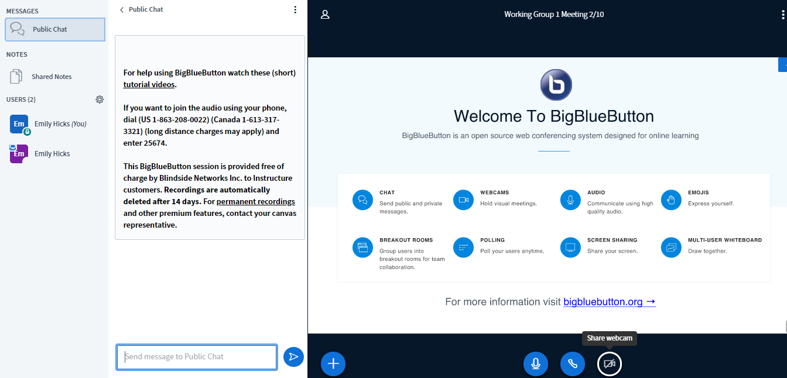

b
c
a

