St Mary’s Seminary & University

Guide to Academic Writing

Mary Reisinger (Ecumenical Institute) Bill Scalia (School of Theology) Emily Hicks (School of Theology)

Introduction

St. Mary’s Seminary & University is a place of great diversity. The School of Theology prepares seminarians from the United States and all over the world for priesthood. The Ecumenical Institute provides advanced theological education for students from many branches of the Church. Members of St. Mary’s student body have various academic, vocational, and cultural backgrounds.

To help equip all students for the academic writing required in theological study, we have prepared this brief guide to common types of writing tasks, general characteristics of effective writing, and the Chicago Manual documentation of sources. Sample papers written by St.
Mary’s students appear in an appendix at the end of the booklet.

The advice in this document is intended to be generally useful. However, preferences vary from one instructor to another. Students should carefully follow the requirements each professor sets for assignments.

We wish all students an inspiring and rewarding experience as they embark on this journey of discovery and transformation.

Acknowledgments

We have appreciated the substantial contributions many of our faculty colleagues have provided. Whether you caught an error, suggested an addition or revision, endorsed a portion of the text, or supplied a sample of student writing, we thank you. We are especially grateful for the support and guidance of Dr. Michael J. Gorman, dean of the Ecumenical Institute; Dr. Pat Fosarelli, Associate Dean of the Ecumenical Institute; Fr. Timothy Kulbicki, dean of the School of Theology; Fr. Edward J. Griswald, Vice Rector of St. Mary’s Seminary & University; and Fr.
Thomas Hurst, President-Rector of St. Mary’s Seminary & University.

Finally, this guide has been shaped by our experience working with many St. Mary’s students. Some of them have graciously allowed their papers to be included here as samples; we thank them. We salute all our students, who teach us a great deal about writing instruction.

Table of Contents
Types of Academic Writing Used in Theological Study 1
Case Study 1
Critique (sometimes called Review or Critical Response) 1
Essay 1
Exegesis Paper 2
Homily / Sermon 2
In-Class Exam 3
Journals 3
Pastoral Narrative 3
Précis (See Summary) 4
Reflection / Reflection Paper 4
Research Paper 4
Review (See Critique) 5
Sermon (See Homily / Sermon) 5
Summary (sometimes called Précis) 5
Verbatim 5
Effective Academic Writing 5
Unity 5
Support 5
Coherence 5
Correctness 6
Appropriate Style 6
Scholarship 6
Inclusive Language 7
General Guidelines for Research Writing 8
Checklist for Revising and Proofreading 8
Checklist for Revising and Proofreading 9
Academic Integrity and Plagiarism 10
Avoiding Plagiarism 11
Using Quotes 14
Full Direct Quote 14
Block Quote 15
Coordinating Capitalization Style in Quoted Text and in Student Text 17
Additional Note on Capitalization in General Text 18
Chicago Manual Citation of Sources in Notes and Bibliographies 19
Documentation of Sources 19
A Word About Turabian 19
Organization of A Manual for Writers of Term Papers, Theses, and Dissertations by Turabian 19
BOOKS: General Information 20
Examples of Turabian Citations: Books 21
ARTICLES: General Information 22
Electronic, Unpublished, and Special Sources: General Information 23
Citing Catholic Documents Using Turabian 24
Title Pages and Headings 25
Student Writing Samples 26
Exegetical Paper Pastoral Narrative Research Paper
i

Types of Academic Writing Used in Theological Study
Following are brief descriptions of typical assignments that theological students will complete.

The specific requirements of assignments will vary, depending on the class and the professor’s preferences. Students are responsible for carefully following these requirements and asking for clarification when necessary.

Case Study
Purpose: Write details of a specific incident or ruling and respond. Requirements:
- Evaluate key points of the case;
- Analyze the significance of the resulting ruling or action;
- Respond to instructor questions;
- Write in the third person (he/she/it). Organization:
- Summarize the key points and the resulting ruling or action.
- Evaluate the case by responding to instructor questions.

Critique (sometimes called Review or Critical Response)
Purpose: Summarize and evaluate another’s work, such as an article, book or film. Requirements:
- Extended summary (audience, purpose, thesis, development)
- Evaluation of strengths, weakness, and effectiveness
- Recommendations about the usefulness (?) of the work
- Reflection on reviewer’s response
- Citations informal. Page number in parenthesis after quotes and paraphrases. Organization
- Bibliographic Citation at the top of the page (unless indicated otherwise by professor)
- Summary (minimum: one-third/ maximum: three-quarters of the critique)
- Evaluation (minimum: one-quarter/ maximum: two-thirds of the critique)

Essay
Purpose: Extended academic paper which establishes a thesis, supports the thesis, and forms a conclusion based on the support.
Requirements:
- Introduction, thesis, support, conclusion;
- Research and/or referring (?) to a specific text;
- Third person (he/she/it) Organization
- Introduction with thesis
- Supporting paragraphs
- Conclusion

Exegesis Paper

Purpose: Explore the meaning of a passage from Scripture. Requirements:
- Explication: Through research and careful study, consider how the biblical text would have been perceived by its original audience
- Application: Consider what the pericope means to today’s reader
- Developed thesis throughout the paper Organized into the following sections:
- Survey (Overview): introduces the passage and indication of the thesis that will be developed
- Contextual Analysis: describes the historical setting of the text and its literary contexts; this is sometimes divided into separate historical and literary context sections
- Formal Analysis:
  - identifies the passage’s
    - literary form (e.g., lament, healing narrative, etc.)
    - characteristics of this genre as they influence meaning
  - examines the structure and movement of the passage, including indications that the passage can be considered to be a single sense-unit
- Detailed Analysis: analyzes the text verse-by-verse or section-by-section, with special attention to development of the paper’s thesis
- Synthesis (Conclusion): brings together the various kinds of evidence collected to create a conclusion that restates the thesis
- Reflection: considers the implications of the text and/or the thesis of the paper for people today

Homily / Sermon

Purpose: Explain the meaning of a biblical text and its application for the people of God today, within the context of worship- necessary
Requirements:
- Keep in mind that speaking forms are different than writing forms.
- Keep sentence structure simple;
- Make sure the relationship between the subject and object is clear;
- Use language that the audience will understand;
- Follow the instructions of the homiletics professor for the methods and assignment guidelines.
- Note: “homily” most often used by Catholics and “sermon”, message”, or “teaching” by Protestants.

In-Class Exam
An in-class exam will ask the student to respond to a question, or series of questions, in a specified time and specified length. In order to best meet the requirements of the in-class exam, it is important to remember four points:
- Understand what is being asked, and be sure to answer the question. A question might ask the student to consider a number of options or to respond to several aspects of a topic. The question might include language that qualifies the kind of response sought. The student should read the question carefully and be sure to understand what is being asked. As simple as this may seem, answering the question that is being asked—all parts of the question— is the student’s prime responsibility.
- Look for action verbs that direct the response. The question will include terms such as “analyze,” “compare,” “reflect on,” etc., that tell the student how to approach the answer. These terms will determine the specific methodology the student should employ when organizing the response.
- Outline the answer before writing. Because of time limits, order the points of the answer logically before writing. Outlining the answer serves two purposes: the outline serves as a guide to ensure the answer is logically and effectively developed; and the outline provides for the instructor an idea of the student’s intentions if the student does not have time to complete an answer.
- Allow time for outlining and proofreading. The student should allow five minutes of exam time for each of these activities.

Journals
Purpose: Show the development of a student’s thinking as a result of readings, lectures, experiences, etc.
Requirements:
- As assigned by the professor. Be sure to note:
- Length
- Frequency
- Type of content
- Any other guidelines

Pastoral Narrative
Purpose: Describe your pastoral experience and its impact on you. Requirements:
- Describe :
- your response to the experience;
- the influence it has had on your ideas about self, God, and other life issues.
- Evaluate your:
- interpersonal skills (relating with others);
- ability to take the initiative in meet the needs of others;
- ability to find creative solutions to problems.
- Focus on who, what, when, how but NOT why.
o Do not assume the feelings or motivations of others unless they have been clearly stated.
- Reflect on your feelings about the experience.

Précis (See Summary)

Reflection / Reflection Paper
Purpose: Narrate, examine, and evaluate the writer’s personal observations and experiences of a subject.
Requirements:
- Respond to readings, interviews, lectures, or experiences as assigned by the professor;
- Respond to specific questions from the professor;
- Organize, develop and support;
- Use style and language appropriate to the assignment;
- Paraphrase and summarize appropriately. Organization:
- Summarize or evaluate some part of the assigned material;
- Relate this topic to the writer’s own experience or observation of life today.

Research Paper

Writers of research papers choose a topic, formulate a question to answer, collect information from various sources, and present the answer to the question in written form. Best practices with research papers include these:
- The organization of the paper is clear to the reader. The paper contains an introduction, an extended body, and a conclusion. For papers of more than a few pages, the use of subheadings (section titles) throughout the paper can assist the writer to stay focused and the reader to follow the paper’s structure.
- The thesis is clearly stated;
- The paper shows evidence of original thinking and analysis. Sources are used to support the thinking that the writer has developed.
- All information that is paraphrased or quoted is correctly identified. Quotes are accurate. Quoted material is placed within quotation marks or block quoted form. Appropriate documentation indicates the sources of information, interpretations, and quotations.
- Documentation of sources follows Turabian’s Notes-Bibliography style, unless the teacher specifies a different style. In addition to text references (footnotes, endnotes, or parenthetical citations), all sources are identified in a list of sources, normally called the Bibliography or Works Cited.
- As in all academic writing, the paper uses standard American-English grammar, punctuation, capitalization, and spelling; it evidences careful drafting, revision, editing, and proofreading.
- The paper follows the length and format (title page, title, sections, etc.) requirements set out by the professor.

Review (See Critique)
Sermon (See Homily / Sermon) Summary (sometimes called Précis)
Purpose: Briefly describe another work, the work’s intended audience, purpose, thesis, and development.
Organization:
- Bibliographic citation placed at the top of the summary (unless the professor instructs otherwise)
- Citations are informal (page numbers are placed inside parentheses after quotes and paraphrases.

Verbatim
Purpose: Reproduce a conversation related to ministry and explore the content and meaning of this conversation.
Requirements:
- Dialogue;
- Parenthetical description of physical gestures and other details;
- Analysis of the conversation.

Effective Academic Writing
The following six characteristics of academic writing determine how well a writer’s ideas are communicated to the reader. A writer who expresses his or her views clearly, concisely, and precisely helps the reader understand the purpose and ideas of the paper or other assignment without ambiguity or confusion.

Unity
Express the main idea for the writing assignment. There is usually a thesis statement for the paper, a topic sentence (or clear topic) for each paragraph, and a conclusion that restates the thesis. All ideas must be clearly related to the portion of the text. All parts must relate to the thesis of the entire paper.

Support
Academic writing requires adequate and appropriate facts, examples, reasons, and arguments to develop and support the main idea.

Coherence
Organize all the material in a logical order so that it is easy for the reader to follow. According to the assignment, the ideas should be ordered logically. This could be by importance, time, space, general to specific, specific to general, or by some other standard. Use transitional words and phrases to show the reader the relationship of one idea to another.

Correctness
Proofread carefully to eliminate errors such as inaccurate or incomplete factual details, incorrect or non-standard spelling, poor word choice, incorrect punctuation, capitalization errors, lack of grammatical agreement, and incorrect or awkward sentence structure.

Documentation of sources is critical in academic writing, and it should be created according to the required style, which at St. Mary’s is normally the Chicago Manual style as summarized in Turabian. Quoted material should be copied exactly as it appears in the source; any changes that are made must be indicated by editorial brackets: [ ].

Appropriate Style
Academic writing is usually moderately formal; whatever its level of formality, it benefits from these qualities:
- Focus: There is a clear central topic; everything in the paper contributes to developing this topic or idea.
- Vitality: Use action verbs, direct phrasing, minimal passive voice (active: Paul broke the window; passive: The window was broken), and other factors to create lively, energetic prose. Avoid redundancy (unnecessary repeating of ideas).
- Originality: The content may not be original, but the writer avoids clichés (“time will tell”, “one step at a time”) and tired phrases and uses fresh images for clarity.
- Smoothness: Wording and organization, especially transitions, are graceful and easy; they avoid jolting the reader.
- Parallelism: When words, phrases, or clauses are in pairs or series, they should be in similar form. Here is an example of a non-parallel series:
Following Jesus’ crucifixion, the disciples were grief-stricken, confused, and they were afraid.
(adjective) (adjective) (subject + verb)
Correction:
Following Jesus’ crucifixion, the disciples were grief-stricken, confused, and afraid
(adjective) (adjective) (adjective)
- Variety / Interest: The writer creates variety and interest by incorporating different sentence patterns, metaphors, idioms, colorful words, appropriate repetition, and other rhetorical devices. This should be done in moderation.
- Precision: The writer uses appropriate factual material, accurately quoted or paraphrased, to represent the ideas of others, as well as careful, precise wording to articulate his or her own ideas. Precision is an especially important aspect of theological writing.

Scholarship
- Present reasonable analyses, explanations, opinions, critiques of other, conclusions calmly, not emotionally;
- Use credible and respected sources;
- Acknowledge different positions;
- Support claims with evidence and careful argument;
- Quote and paraphrase correctly in order to avoid plagiarism;
- Construct citations and bibliographies correctly.

Inclusive Language
Writers should avoid language that makes assumptions about gender.

When those being described could be of either gender, consider these options:
  - Use gender-neutral terms
  - Use the plural form for nouns and pronouns
  - Include both male and female pronouns

Non-inclusive wording Gender-neutral alternatives
mankind, men (meaning males and females) humankind, people, humanity, human beings policeman, policewoman police officer
mother, fathers parents, guardians, caregivers
girls, boys children, young people, teenagers

Each student planned his presentation. The students planned their presentations.
Each student planned his or her presentation.

Examples:
Our congregation hopes to hire a parish nurse who has completed her training.
[Not all parish nurses are women.]

Possible solution: Our congregation hopes to hire a parish nurse who has completed training.

The wives of clergy will tour the city center during the conference.
[Not all clergy marry. Of those who do, not all are men; thus, the spouses may be male or female. Further, it cannot be assumed that none of these people have a part in the conference, or that they would all choose to take a tour.]

Possible solution: Spouses of clergy who wish to do so will tour the city center during the conference.

Everyone must either write a thesis or take a comprehensive examination in order to receive his
master’s degree.
[Not all students are men. One solution, matching “everyone” with “their,” does not work because “everyone” is considered a singular word and the pronoun “their” is plural; therefore, these two words do not agree.]

Possible solutions:
All students must either write a thesis or take a comprehensive examination in order to receive their master’s degrees.

All students must either write a thesis or take a comprehensive examination in order to graduate.

Members of the board will elect a chairman.
[Not all candidates for this position will be men.]

Possible solution: Members of the board will elect a chairperson.

General Guidelines for Research Writing
Use correct form for citations and source lists; even periods, commas, and spaces matter. Attention to these details is part of a scholarly habit of being careful, thorough, and precise.

Consult a variety of good scholarly sources—journals, books, and relevant websites, among others—as appropriate for the nature of the assignment.

Unless directed otherwise by your professor, include only the works that are cited in the body of the paper and/or notes in the bibliography.

Use enough sources to effectively support the paper’s overall thesis and its subordinate claims.

Be careful not to rely too much on quoted material. Strive for balance between your own analyses and quoted or paraphrased material. Appropriate reference to source material will generally result in approximately one to three footnotes per page of text.

Checklist for Revising and Proofreading
An essential part of successful writing is revising and proofreading your work.

Schedule your writing to allow enough time for adequate revision, editing, and proofreading. If possible, have a fellow student read over your paper; often a second reader can catch proofreading errors that escape the writer. Also, read your paper aloud in the proofreading stage.

As you become familiar with your individual tendencies as a writer (pay attention to comments from knowledgeable readers and on your graded papers), you can focus your proofreading skills to concentrate on areas of particular concern to you.

On the next page is a checklist you can use to help in the revision and proofreading process. Feel free to make photocopies!

Checklist for Revising and Proofreading
Requirements
    - Does my paper address the questions or tasks of the assignment?
    - Does my paper conform to length, line spacing, page numbering, and other requirements?
    - Have I checked for misspellings and typos?
    - Is the content accurate and complete?

Structure

- Do I have an introduction?
- Do I have a clear thesis statement?
- Does my paper focus on the topic?
- Do I avoid unnecessary repetition?
- Do I have an appropriate balance of research and analysis / critique?
- Do I have a conclusion that restates the thesis?

Paragraphs
  - Does each paragraph focus on a single point?
  - Does each sentence focus on the main idea of the paragraph?
  - Is each paragraph sufficiently developed?
  - Are the sentences ordered logically?
  - Is there an adequate transition between paragraphs?

Sentences

- Are my sentences grammatically complete (subject / verb / complete thought)?
- Does each sentence support my thesis?
- Can I eliminate wordiness?
- Have I used the active voice?
- Have I varied the style and length of my sentences?
- Have I avoided slang, clichés, and idiomatic expressions?
- Have I avoided using wording such as “There was,” or “It is” at the beginning of sentences?

Punctuation and Capitalization
  - Have I used commas properly?
  - Can I eliminate unnecessary commas?
  - Do my sentences end with the appropriate punctuation?
  - Have I enclosed my direct quotes inside quotation marks?
  - Is capitalization consistent throughout the paper?

Grammar

- Do the subject and verb agree in every sentence?
- Is verb tense logical and consistent?
- Do my pronouns have clear antecedents?
- Do my pronouns and nouns agree?
- Have I used the apostrophe correctly (to indicate contraction or possession)?

Documentation
  - Does my paper conform to the required formatting style (Turabian, MLA, etc.)?
  - Are my citations and footnotes in the correct form?
  - Is the punctuation in my citations and footnotes correct?
  - Have I created a citation for every quote and paraphrase?
  - Is every quote copied accurately from the source?

Academic Integrity and Plagiarism
Students are responsible for the honesty and truthfulness of all of their academic work. Academic dishonesty is absolutely unacceptable and includes:
- cheating;
- plagiarizing;
- falsely creating sources, information, or quotations;
- sharing one’s assignment with another student or collaborating with another student [or with other students] on an assignment without the professor’s permission;
- submitting work other than one’s own;
- engaging in all other types of dishonesty in research and writing.

Students should already have basic skills in library usage, reading and research, writing term papers, and acknowledging sources. Written work must be the student’s own, and each student must give full documentation for all material quoted or paraphrased from other sources, including the Internet.
Standards:
- Chicago Manual documentation is the standard for both the School of Theology and the Ecumenical Institute.
- The standard reference work is Kate L. Turabian, A Manual for Writers of Term Papers, Theses, and Dissertations.
- In some classes, professors will allow or require MLA or APA documentation; in these cases, students should consult appropriate references.

Students should note that stringing a series of quotations and/or ideas from other sources together, even when they are properly documented, does not constitute an original paper. At the discretion of the professor, such work may be deemed a failure or returned for revision.

Plagiarism is perhaps the most common form of academic dishonesty. We define plagiarism as the use of another person’s ideas or words without appropriately indicating them as such.
Examples of plagiarism include:
- Any direct use of another’s words without properly indicating such use (including the appropriate use of quotation marks or indentation), without attributing the words accurately and exactly, and / or without properly documenting the source;
- Any use of another’s words that is too similar to the original source;
- Any indirect use (e.g., by paraphrasing or summarizing) of another’s ideas, arguments, thesis, or organizational structure without attributing and documenting those ideas or structures;
- Buying, downloading, or copying someone else’s work and passing it off as one’s own.

Proper presentation and documentation of another’s words and/or ideas includes:
- Direct quotations: use of quotation marks and/or indented block quotes, plus specific source attribution in a parenthetical note, footnote, or endnote;
- Indirect quotations, paraphrases, and summaries: general acknowledgment of the source in the body of the text, plus specific source attribution in a parenthetical note, footnote, or endnote.

All forms of academic dishonesty are serious offenses and grounds for grave consequences; these may include one or more of the following: required revision of the assignment, failure of the assignment, failure of the course, academic probation, and dismissal from the School of Theology and/or the Ecumenical Institute.

Avoiding Plagiarism
Quote (use within quotation marks the exact words of the original material) and paraphrase (express the ideas of the source material in different words without quotation marks) source material correctly. Document appropriately.

The following examples are from page 3 of Peter Berger, The Sacred Canopy: Elements of a Sociological Theory of Religion. New York: Doubleday, 1967.
Original text:
Society is a dialectic phenomenon in that it is a human product, and nothing but a human product, yet that continuously acts back upon its producer. Society is a product of man. It has no other being except that which is bestowed upon it by human activity and consciousness. There can be no social reality apart from man. Yet it may also be stated that man is a product of society. Every individual biography is an episode within the history of society, which both precedes and survives it. Society was there before the individual was born and it will be there after he has died. What is more, it is within society, and as a result of social processes, that the individual becomes a person, that he attains and holds onto an identity, and that he carries out the various projects that constitute his life.
Man cannot exist apart from society. The two statements, that society is the product of man and that man is the product of society, are not contradictory. They rather reflect the inherently dialectic character of the societal phenomenon. Only if this character is recognized will society be understood in terms that are adequate to its empirical reality.

Student sample paragraph 1:
Society is a human product. Society is made up of individuals, who at the same time are defined by the society they belong to. Each person’s life is an episode in the history of society, which precedes it and survives it. However, these two statements, that man makes society and that society precedes the individual and exists after him, are not in contradiction. The fact that they are not contradictory defines the dialectical character of society. This character must be recognized if society is understood in relation to its empirical reality.
This paragraph represents plagiarism in its most basic form because the student uses Peter Berger’s ideas and language without any attribution or citation. Whether this is intentional or accidental on the part of the student, the instructor must assume that the student has made the choice to use Berger’s material in this way. The student must be aware that any material or usage not his or her own must be attributed and the proper citation given.

Student sample paragraph 2:
Peter Berger uses the term “dialectic” to describe the relationship between the individual and society. Society is a human product that continually acts back upon the individuals who produce it. Every individual life is a piece of the larger society, even though society precedes and survives the individual. While there is no social reality apart from man, the individual gains identity only inside the society. The two ideas that society is a product of man and that man is a product of society are not contradictory, but define a dialectic relationship that is the inherent character of society.
Even though the student refers to the author in the first sentence, the author’s original language
and sentence structure are copied without citation. The student has changed some of the words of Berger’s statements, but the ideas those words represent are Berger’s, not the students. Therefore, citation must be used to attribute the source.

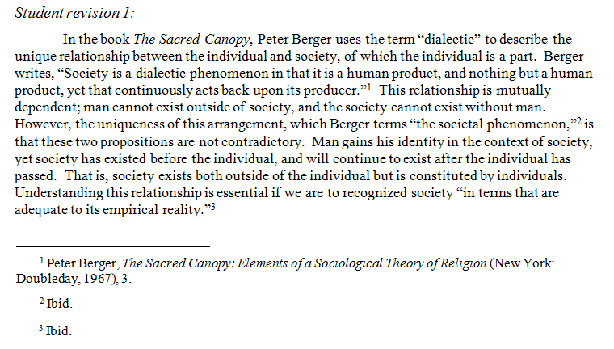
Here are two ways the student might address the problem:
The student has identified the source text correctly at the beginning of the paragraph.
In places where Berger’s original language is necessary for his definition of the term, the student has quoted Berger directly and cited the quotes.

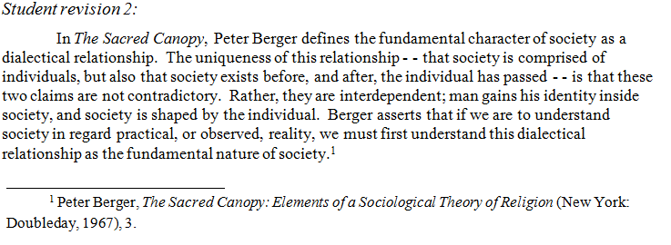
The student has used his own language and sentence structure.
The student has still cited the source text.

This paraphrasing strategy shows the instructor that the student has read Berger carefully and is able to express the idea in his own words.

Using Quotes
Listed below are three main ways to use quotes correctly:
  - Full direct quote
  - Blended quote (integration of quoted material into writer’s own sentences)
  - Block quote
(From Peter Berger, The Sacred Canopy: Elements of a Sociological Theory of Religion. New York: Doubleday, 1967.)

Original text:
Society is a dialectic phenomenon in that it is a human product, and nothing but a human product, yet that continuously acts back upon its producer. Society is a product of man. It has no other being except that which is bestowed upon it by human activity and consciousness. There can be no social reality apart from man. Yet it may also be stated that man is a product of society. Every individual biography is an episode within the history of society, which both precedes and survives it. Society was there before the individual was born and it will be there after he has died. What is more, it is within society, and as a result of social processes, that the individual becomes a person, that he attains and holds onto an identity, and that he carries out the various projects that constitute his life. Man cannot exist apart from society. The two statements, that society is the product of man and that man is the product of society, are not contradictory. They rather reflect the inherently dialectic character of the societal phenomenon. Only if this character is recognized will society be understood in terms that are adequate to its empirical reality.

Full Direct Quote
The student may choose to allow the author to state a claim in his own language if the student feels that he or she is unable to paraphrase the material effectively. A full quote is material taken in complete statements from the original text. In this case, the student must be careful to introduce the quote, and remember to quote accurately. 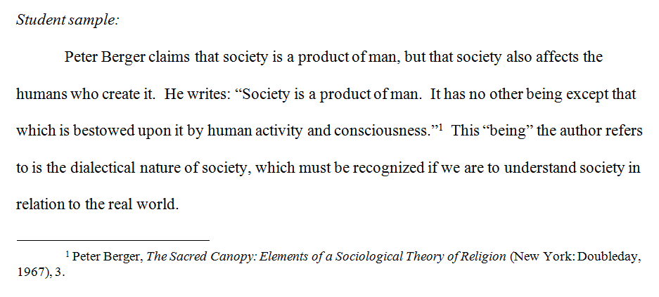
A full quote must be introduced in the body of the student’s own paragraph.
The student introduces the quote with the phrase “He writes . . .”

The student may also choose phrases such as “According to Berger . . .”, “The author states . .
.”, or some other appropriate variation.

Block Quote
An extended direct quote may be used if an author’s ideas suggest a complexity that is best given in the author’s own language.
About block quotes:
- When a direct quote extends to four or more lines of text in a student’s paper, the quoted material should be formatted in block quote form.
- Block quotes must be introduced by

complete sentences ending in a period(.),
  - a colon (:),

formal introductory phrases followed by a colon (According to Berger:).
- Block quotes should be indented from the left margin and single spaced;
- Block quotes do not use quotation marks to designate the quote.
- Double quotation marks are used for material that is quoted within the block quote (in the source).

Here the student has allowed Berger to state in his own language his original argument. 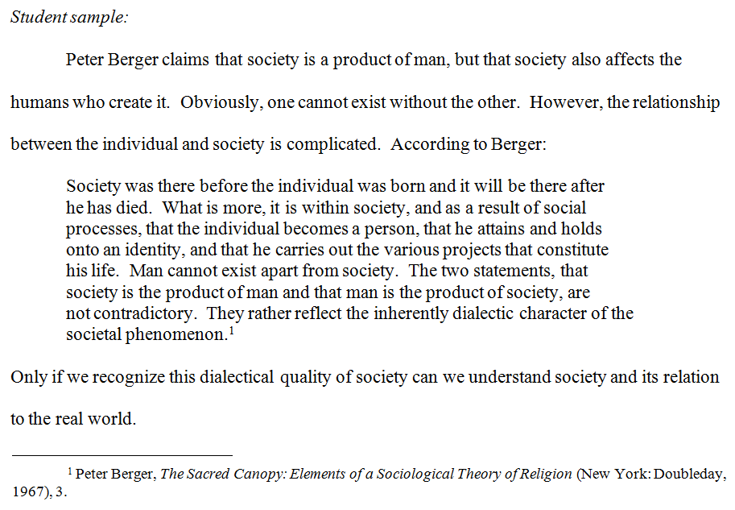
Here the student has allowed Berger to state his original argument in Berger’s own words.
Note that though no quotation marks are used, the material must still be noted and cited appropriately.

Blended Quote
A blended quote combines the student’s language with that of partially quoted material. The blended quote demonstrates that the student understands the material and is able to paraphrase, but recognizes that the author’s own unique language or phrasing better expresses key ideas.
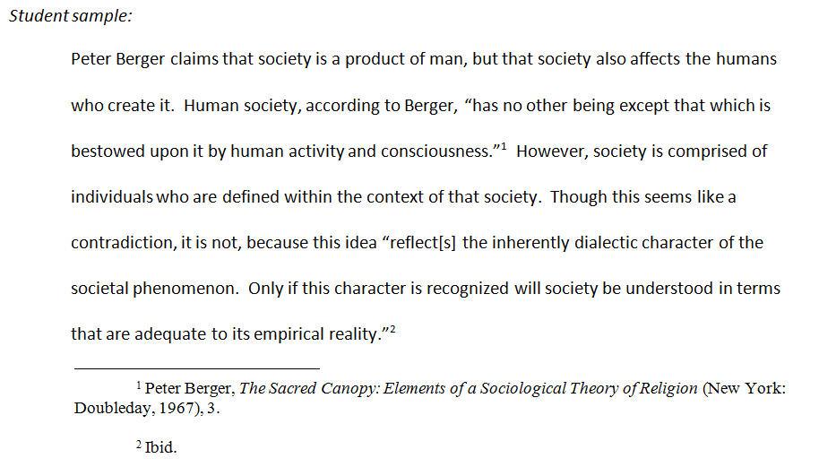
The quoted material is introduced.
The student has changed the plural verb form “reflect” from the original material to the singular “reflects” to keep the blended sentence grammatically correct.
Keep in mind:
Changes made to make sentences grammatically correct must be shown in brackets. [ ]. Any change to exact wording or punctuation must be enclosed in brackets [ ]

Coordinating Capitalization Style in Quoted Text and in Student Text
Capitalization of nouns and pronouns referring to God, Jesus, or the Holy Spirit should be consistent and should adhere to the instructor’s preference, if any is stated. Occasionally the student’s style will not agree with the style of an author the student chooses to quote. In that case, the student is obliged to preserve exactly the author’s style in direct quotes while maintaining his or her own style in the paper. Following are examples of consistency in capitalization styles when quoting:
“In his being as Son Jesus has his radical origin in God and radically belongs to God. The turning of Jesus to the Father implies the prior turning of the Father to Jesus. The relation of Jesus to the Father implies the prior relation of the Father to him, the self-communication of God to him. The subsequent Son-christology is therefore simply the interpretation and translation of what is secretly present in Jesus’ obedience as Son and his self-surrender as Son.”

Original text:
“In his being as Son Jesus has his radical origin in God and radically belongs to God. The turning of Jesus to the Father implies the prior turning of the Father to Jesus. The relation of Jesus to the Father implies the prior relation of the Father to him, the self-communication of God to him. The subsequent Son-christology is therefore simply the interpretation and translation of what is secretly present in Jesus’ obedience as Son and his self-surrender as Son.”
Kasper capitalizes the nouns referring to God and Jesus (Father; Son),
but does not capitalize the pronouns referring to Jesus (him; his)

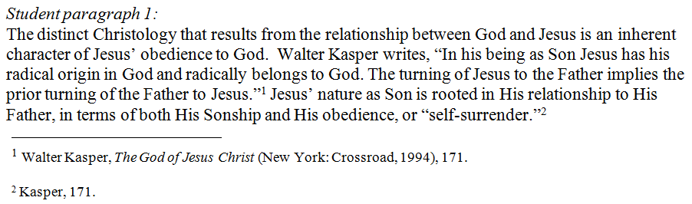
Walter Kasper, The God of Jesus Christ (New York: Crossroad, 1994), 171.
The student has been consistently capitalizing the pronoun and has correctly continued to do so here in the student’s own text.
Within quoted text, the student accurately
copies the source. (his, not His)
Also, Kasper does not capitalize the noun “christology,” while the student does; this too is a
matter of consistency.

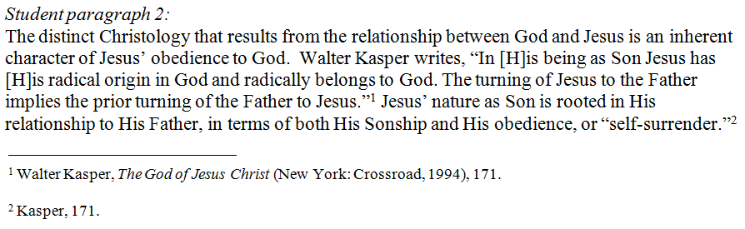
In this sample, the student has chosen to change Kasper’s style to match the student’s own. Note that the student has made the change by including the capitalized pronoun in editorial brackets [ ].

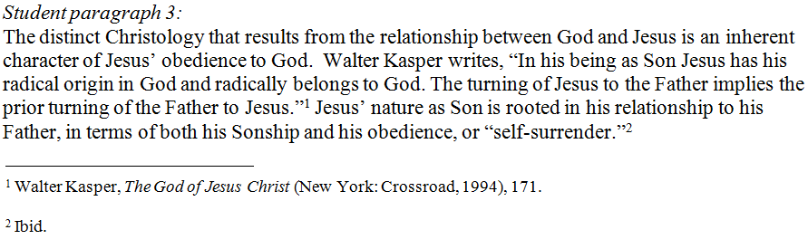

The student here does not capitalize the pronouns in the essay, an acceptable style as long as the usage is consistent. Note that in this case the student’s style happens to correspond with Kasper’s.

Additional Note on Capitalization in General Text
Some words should always be capitalized. One of these words is the word ‘Bible’. Unlike other titles of books, this does not need to be italicized, but it does need to be capitalized.

The word ‘biblical’ does not usually need to be capitalized.

The teacher asked students to bring their Bibles to the class on biblical interpretation.

For some words, capitalization depends on the way the word is being used. The word church is not capitalized when it refers to a place of worship or a congregation. It is capitalized when it refers to the institution of religion or when it is part of a complete name of a congregation.
Place of worship
Part of the name of a congregation

In Holy Cross Church, as in many churches throughout the country, people discussed the law concerning separation of Church and State.
Refers to the institution of religion

Words naming God are usually capitalized, but modifiers (such as adjectives) and other nouns usually are not.

The one divine, eternal, omnipotent God came to us in human form as a baby, who was named Jesus.
modifiers

Chicago Manual Citation of Sources in Notes and Bibliographies
(Many examples are from a guide compiled by Fr. Paul Zilonka & Dr. Michael Gorman or from Writing Theology Well: A Rhetoric for Theological and Biblical Writers, 2006, by Lucretia B. Yaghjian.)

Documentation of Sources
In your research papers, it is important to provide accurate citation and complete bibliographical documentation of your sources. Following are citation examples based on the guidelines found in Kate L. Turabian, A Manual for Writers of Term Papers, Theses, and Dissertations, 8th ed., revised by Wayne C. Booth, Gregory G. Colomb, Joseph M. Williams, and University of Chicago Press Editorial Staff (Chicago: University of Chicago Press, 2007).

A Word About Turabian
There is a book called The Chicago Manual; however, Kate L. Turabian, former dissertation secretary of the University of Chicago, wrote a brief guide to The Chicago Manual’s methods of documentation for academic writers. This became a book, A Manual for Writers of Term Papers, Theses, and Dissertations. The current edition of this book is the standard reference
used at St. Mary’s Seminary & University, both in the School of Theology and the Ecumenical Institute.1
Within the Turabian reference, two variations of CM documentation are explained:
  - Notes-Bibliography Style
  - Parenthetical Citations-Reference List Style

At St. Mary’s, students use Notes-Bibliography Style. The sample notes* and bibliographic entries here are based on Turabian’s 8th edition Notes-Bibliography Style.
*Terminology: “Note” stands for either footnotes or endnotes. The only difference between these two forms is that footnotes appear at the bottom of the page where the cited material appears. Endnotes appear at the end of the text, at the end of the document, chapter, or book, for example. Generally, footnotes are the preferred type of note at St. Mary’s.

Organization of A Manual for Writers of Term Papers, Theses, and Dissertations by Turabian

Part 1: From Planning to Production
These chapters detail how to plan and conduct research and write a research paper. There is excellent information here about forming a hypothesis, choosing and learning from sources, drafting, and revising.

Part 2: Source Citation
Chapter 15 is a general introduction to citing sources. Chapters 16 and 17 show how to document sources in the Notes-Bibliography Style. These are the chapters St. Mary’s students should consult.

Chapters 18 and 19 explain the Parenthetical Citations-Reference List Style of documentation. This is NOT the standard style used at St. Mary’s. St. Mary’s students do NOT need to consult these chapters unless professors request use of Chicago Manual parenthetical citations.

1 Some disciplines require other documentation systems such as MLA (Modern Languages Association) or APA (American Psychological Association). When that is the case, please consult the appropriate references.

Part 3: Style
In these chapters, students will find advice on various stylistic topics ranging from spelling to incorporating tables and figures into the document. St. Mary’s students should carefully review Chapter 25 on correct ways to quote sources and avoid plagiarism.

Below are a few typical types of entries in their Note and Bibliographic formats. Consult chapters 16 and 17 of Turabian for more detail, especially for types of entries not covered here.

BOOKS: General Information
Footnotes or Endnotes for Citations from and References to Books
The first line only is indented. Generally, a comma separates items from each other. Each note ends with a period.

Author’s first name + last name, Book title [italicized2]: subtitle [if any, also italicized and preceded by a colon], Name of editor or compiler or translator [if any], Number or name of edition [if other than the first], Name of series [if any; not italicized, with headline capitalization], volume or number in the series (Publishing information within parentheses — Place of publication [omit state or country for major cities] + colon: Publisher [may omit “Press” if not a University Press; also omit “The” when it is the first word and words or abbreviations such as “Co.”], Date), Page number(s) of specific citation [Do not use “page” or abbreviations such as p. or pp.].
2Jon D. Levenson, The Death and Resurrection of the Beloved Son (New Haven, CT: Yale University Press, 1993), 129.

Shortened Form for Subsequent Footnotes
For notes that follow immediately after a note for the same source, the abbreviation Ibid. may be used, unless the professor instructs otherwise. If all the information except the page number is the same, use Ibid., page number.
3Ibid., 134.
For subsequent notes that do not follow immediately after notes for the same source, use a shortened form that includes the author’s last name, a shortened form of the title, and the page reference.
11Levenson, Death and Resurrection, 128.

Bibliography Format for Books
The first line begins at the left margin; subsequent lines are indented. Generally, a period separates items. Each entry ends with a period.

Author’s last name, first name. Book title [italicized]: subtitle [if any; also italicized and preceded by a colon]. Name of editor or compiler or translator [if any]. Number or name of edition [if other than the first]. Name of series [if any; not italicized]. Volume or number in the series. Publishing information with no parentheses
— Place of publication [omit state or country for major cities]+ colon: Publisher [may omit ‘Press’ if not a University Press], Date [most recent year if there are multiple years given].

Levenson, Jon D. The Death and Resurrection of the Beloved Son. New Haven, CT: Yale University Press, 1993.

2 When information is being written by hand or italicization is not available, the alternate method of identifying book and periodical titles is to underline. DO NOT underline when italics are available.

Examples of Turabian Citations: Books

Simple book
Note | 2Craig R. Koester, Symbolism in the Fourth Gospel (Minneapolis: Fortress, 1995), 21.
Bibliographic Entry | Koester, Craig R. Symbolism in the Fourth Gospel. Minneapolis: Fortress, 1995.
Book in a numbered series with editor other than the author
Note | 2Francis J. Moloney, The Gospel of John, Sacra Pagina 4, edited by Daniel J. Harrington (Collegeville, MN: Liturgical, 1998), 129.
Bibliographic Entry | Moloney, Francis J. The Gospel of John. Sacra Pagina 4, edited by Daniel J. Harrington. Collegeville, MN: Liturgical, 1998.
Book in a numbered series when author is also editor
Note | 3Daniel J. Harrington, The Gospel of Matthew, Sacra Pagina 1 (Collegeville, MN: Liturgical, 1991), 164.
Bibliographic Entry | Harrington, Daniel J. The Gospel of Matthew. Sacra Pagina 1. Collegeville, MN: Liturgical, 1991.
Book in which author’s work is translated or edited by another
Note | 2Raymond E. Brown, An Introduction to the Gospel of John, ed. Francis  J. Moloney (New York: Doubleday, 2003), 125.
Bibliographic Entry | Brown, Raymond E. An Introduction to the Gospel of John. Edited by Francis J. Moloney. New York: Doubleday, 2003.
Two authors [here also in a series with an editor]
Note | 2Philip J. King and Lawrence E. Stager, Life In Biblical Israel, Library of Ancient Israel, ed. Douglas A. Knight (Louisville: Westminster John Knox, 2001), 135.
Bibliographic Entry | King, Philip J. and Lawrence E. Stager. Life In Biblical Israel. Library of Ancient Israel, edited by Douglas A. Knight. Louisville: Westminster John Knox, 2001.
More than three authors
Note | 2Bruce C. Birch et al., A Theological Introduction to the Old Testament  (Nashville: Abingdon, 1999), 136.
Bibliographic Entry | Birch, Bruce C., Walter Brueggemann, Terence E. Fretheim and David L. Petersen. A Theological Introduction to the Old Testament. Nashville: Abingdon, 1999.

ARTICLES: General Information
Footnotes or Endnotes for Citations from and References to Articles
The first line only is indented. Generally, a comma separates items from each other. Each note ends with a period.
Author’s first name + last name, “Article Title: subtitle [if any, also placed within quotation marks and preceded by a colon],” Title of Journal [italicized] Volume, no. Number [if either or both], (Date of Publication): Page number of specific citation [do not use the word “page” or abbreviations such as p. or pp.].

2Michael W. Harris, “African American Religious History in the 1980s: A Critical Review,” Religious Studies Review 20, no. 4 (1994): 265.
Shortened Form for Subsequent Footnotes
[Note: Some faculty members do not allow Ibid. or restrict the use of Ibid. to same page footnotes only. Please check with your professor.]

Use Ibid. for notes that follow immediately after notes for the same source. For other subsequent notes, use a shortened form that includes the author’s last name, a shortened form of the title, and the page reference. [Note placement of comma inside end quotation mark after the article title.]
2Harris, “African American Religious History,” 275.

Bibliography Format for Articles
The first line begins at the left margin; subsequent lines are indented. Generally, a period separates items. Each entry ends with a period.
Author’s last name, first name. “Article Title [including colon and subtitle if any].” Title of Journal Volume, no.
Number [if either or both] (Date of Publication): xx-yy (Range of pages for entire article).

Harris, Michael W. “African American Religious History in the 1980s: A Critical Review.” Religious Studies Review 20, no. 4 (1994): 263-75.

Examples of Turabian Citations: Articles

Article in a journal
Note | 2Xavier Léon-Dufour, “Reading the Fourth Gospel Symbolically,” New Testament Studies 27 (1980-81): 442.
Bibliographic Entry | Léon-Dufour, Xavier. “Reading the Fourth Gospel Symbolically.” New Testament Studies 27 (1980-81): 439-56.*
 | *Note: The colon shown here is used before page numbers only for journal articles; for books, chapters in books, etc., a comma is used.
Signed Article in Edited Book/Encyclopedia/Dictionary
Note | 2Richard J. Dillon, “Acts of the Apostles,” in The New Jerome Biblical Commentary, ed. Raymond E. Brown et al. (Englewood Cliffs, NJ: Prentice Hall, 1990), 745.
Bibliographic Entry | Dillon, Richard J. “Acts of the Apostles.” In The New Jerome Biblical Commentary, ed. Raymond E. Brown, Joseph A. Fitzmyer, and Roland E. Murphy. 722-767. Englewood Cliffs, NJ: Prentice Hall, 1990.

Electronic, Unpublished, and Special Sources: General Information

Footnotes or Endnotes for Citations from and References to Articles in Online Journals The first line only is indented. Generally, a comma separates items from each other. Each note includes the URL and Date of Access and ends with a period. For articles that have a DOI, eg 10.1086/660696, add “http://dx.doi.org/” before the DOI and use it in the place of a URL. For example: http://dx.doi.org/10.1086/660696. Database names may be used instead of a URL.

Author’s first name + last name, “Article Title: subtitle [if any, also placed within quotation marks and preceded by a colon],” Title of Journal [italicized] Volume, no. Number [if either or both], (Date of Publication), Page Number [if available] OR under “Descriptive
Locator, [if necessary to give reader location; an example would be a heading that appears above the text],” accessed Month dd, yyyy [date on which you read the electronic source], URL.

²Hanna Stettler, “Sanctification in the Jesus Tradition,” Biblica 85 (2004): 265, accessed April 3, 2005, http://www.bsw.org/project/biblica/bibli85.html.

Shortened Form for Subsequent Footnotes
Use Ibid. for notes that follow immediately after notes for the same source. For other subsequent notes, use a shortened form that includes the author’s last name, a shortened form of the title, and the page reference. [Note placement of comma inside end quotation mark after the article title.]

²Stettler, “Sanctification,” 265.

Bibliography Format for Articles in Online Journals
The first line begins at the left margin; subsequent lines are indented. Generally, a period separates items. Each entry contains the URL and access date and ends with a period. For articles that have a DOI, eg 10.1086/660696, add “http://dx.doi.org/” before the DOI and use it in the place of a URL. For example: http://dx.doi.org/10.1086/660696. Database names may be used instead of a URL.

Author’s last name, first name. “Article Title [including colon and subtitle if any].” Title of Journal Volume, no. Number [if either or both] (Date of Publication): xx-yy (Range of pages for entire article, if available). Accessed [month dd, year]. URL/database.

Stettler, Hanna. “Sanctification in the Jesus Tradition.” Biblica 85 (2004): 153-78. Accessed April 3, 2005. http://www.bsw.org/project/biblica/bibli85.html.

Note: URLs are lengthy; sometimes it is necessary to insert a space into the URL so that the lines in the citation can break normally. Insert the space between parts of the URL, never in the middle of a “word.”

Other Electronic Sources
For information on documenting other electronic sources such as electronic books, websites, and
online reference works, please consult Turabian, primarily chapters 16 and 17, with special attention to 15.4, 16.1.7, 17.1.7, 17.1.8, 17.1.10, 17.2.7, 17.5.9, 17.7, 17.8.6, and 17.9.13.
Unpublished Sources
Generally, instructors do not require course lectures or class discussions to be cited as source
material. However, lectures outside of class, as well as personal interviews, may be used a source material and must be cited. Unpublished sources may be used so long as they are cited. A typical citation will need the author’s name, the title of the work (if there is one), what it is (eg. manuscript, journal, photograph, letter, etc.), date, and where it can be found.

Author’s last name, first name. “Title [including colon and subtitle if any].” Document type, where found/given, date.

Smith, Jane J. “St. Mary’s: An Historical Analysis.” PhD diss, St. Mary’s Seminary & University, 2016.

For Footnotes:
Auther’s first name last name, “Title [including colon and subtitle if any],” document type, where found/given, date.

²Jane J. Smith, “St. Mary’s: An Historical Analysis,” PhD diss, St. Mary’s Seminary & University, 2016.

Personal Interview
In citations for interviews and personal communications, the name of the person interviewed or
the person from whom the communication is received should be listed first. This is followed by the name of the interviewer or recipient, if given, and supplemented by details regarding the place and date of the interview/communication. Unpublished interviews and personal communications (such as face-to-face or telephone conversations, letters, e-mails, or text messages) are best cited in text or in notes rather than in the bibliography:

²Fr Thomas Burke in discussion with the author, September 2013.

³Fr Edward Griswold, e-mail message to the author, September 2013.

Special Types of Sources
For use of the Bible and other sacred texts, see Turabian 17.5.2 and 24.6. Cite biblical sources
parenthetically or in notes, using traditional or shortened abbreviations for the names of books and Arabic numerals for chapters and verses and the version on the first reference: 1 Cor. 6:1-10 (NAB). For use of encyclopedias and dictionaries, see Turabian 17.5.3. Usually, these sources will be cited in notes, but not in bibliographies. For sources and information not covered in Turabian, see the SBL Handbook of Style (Hendrickson, 1999), which is available in the library.

Citations of Catholic Sources Using Turabian

Papal Documents

Note: ¹⁰Pope Benedict XVI, Encyclical Letter. Caritas in Veritate [Charity in Truth] (Vatican / Washington, DC: USCCB, 2009), 3.
Bib: Benedict XVI, Pope. Encyclical Letter. Caritas in Veritate [Charity in Truth]. Vatican / Washington, DC: USCCB. 2009.

Note: ¹¹Pope John Paul II, Apostolic Exhortation, Catechesi Tradendae [Catechesis in Our Time] (Vatican / Washington DC: USCCB, 1979), 18.
Bib: John Paul II, Pope. Apostolic Exhortation, Catechesi Tradendae [Catechesis in Our Time].Vatican / Washington, DC: USCCB. 1979.

Note: ¹²Pope John Paul II, Apostolic Letter, Rosarium Virginis Mariae [On the Most Holy Rosary] (Vatican / Washington, DC: USCCB, 2002), 25.
Bib: John Paul II, Pope. Apostolic Letter, Rosarium Virginis Mariae [On the Most Holy Rosary].Vatican / Washington: USCCB. 2002.

Note: ¹³Pope Pius XII, Encyclical Letter. Humani Generis [Concerning Some False Opinions Threatening to Undermine the Foundations of Catholic Doctrine] (Vatican, 1950), 12.
Bib: Pius XII, Pope. Encyclical Letter. Humani Generis [Concerning Some False Opinions Threatening to Undermine the Foundations of Catholic Doctrine]. Vatican. 1950.

Roman Curia

Note: ¹⁴Congregation for Divine Worship and the Discipline of the Sacraments, Instruction, Redemptionis Sacramentum [Instrucion on certain matters to be observed or to be avoided regarding the Most Holy Eucharist] (Vatican, 2004), 87.

Bib: Congregation for Divine Worship and the Discipline of the Sacraments. Instruction, Redemptionis Sacramentum [Instrucion on certain matters to be observed or to be avoided regarding the Most Holy Eucharist]. Vatican. 2004.

Note: ¹⁵Congregation for the Doctrine of the Faith (CDF), Doctrinal Document, Dignitas Personae [Instruction on Certain Bioethical Questions] (Vatican, 2008), 12.

Bib: Congregation for the Doctrine of the Faith (CDF). Doctrinal Document, Dignitas Personae
[Instruction on Certain Bioethical Questions]. Vatican. 2008.

Note: ¹⁶Congregation for Catholic Education. “Guidelines for the Use of Psychology in the Admission and Formation of Candidates for the Priesthood” (Vatican, 2008), 2.

Bib: Congregation for Catholic Education. “Guidelines for the Use of Psychology in the Admission and Formation of Candidates for the Priesthood”. Vatican. 2008

Note: ¹⁷Synod of Bishops. XII Ordinary General Assembly: The Word of God in the Life and Mission of the Church, “Message to the People of God at the Conclusion of the XII Ordinary Assembly (Vatican, 2008), 8.

Bib: Synod of Bishops. XII Ordinary General Assembly: The Word of God in the Life and Mission of the Church, “Message to the People of God at the Conclusion of the XII Ordinary Assembly. Vatican. 2008.

Vatican Documents

Note: ¹⁸Vatican Council II, Gaudim et Spes [Pastoral Constitution on the Church in the Modern World]. In Vatican Council II: The Conciliar and Post Conciliar Documents, vol. 1, ed.
Austin Flannery, O.P., 5th ed., rev. ed. (Northport, NY: Costello Publishing Company, 2004), 10.

Bib: Vatican Council II. Gaudim et Spes [Pastoral Constitution on the Church in the Modern World]. In Vatican Council II: The Conciliar and Post Conciliar Documents. Vol. 1. Edited by Austin Flannery, O.P., 910­911. 5th ed. Rev. ed. Northport, NY: Costello Publishing Company, 2004.

USCCB Documents

Note: ¹⁹USCCB. Go and Make Disciples, A National Plan and Strategy for Catholic Evangelization in the United States (1993; repr., Washington, DC: USCCB, 2002), 4­5.

Bib: USCCB. Go and Make Disciples, A National Plan and Strategy for Catholic Evangelization in the United States. 1993. Reprint, Washington, DC: USCCB, 2002.

Classical Theological Works

Note: ²⁰Thomas Aquinas, Summa Theologiae (henceforth cited as ST) I, 103.4, trans. the Fathers of the English Dominican Province, (New York: NY, Benziger Brothers, 1948).

Abbreviated Note: ²¹ST I­II, 90.1

Bib: Aquinas, Thomas. Summa Theologiae. Translated by the Fathers of the English Dominican Province. New York: NY, Benziger Brothers, 1948.

Title Pages and Headings
Following are title pages and headings that can serve as models. These are not standard required forms; individual professors may have specific requirements for when to use title pages, when to use headings on the first page of the paper, and what form these should take.

Title Page (based on Turabian guidelines)

Major Forms of Christian Art: From Mosaics to Stained Glass

Lee Witherall SP702.1
May 5, 2010

- Center the title about one third of the way down the page.

- If there is a subtitle, place a colon after the main title and type the subtitle on the next line.

- About a third of the way from the bottom of the page, type your name and other information requested by the instructor such as the course number and date.

- Do not insert page numbers on the title page.

Headings on First Page of Paper
Lee Witherall SP702.1
May 5, 2010

Major Forms of Christian Art: From Mosaics to Stained Glass

- Turabian notes that titles may be on the first page of a paper, but the book does not provide a model.

- The example illustrated to the right includes the student’s name, the class identification, and the date in a heading.

- The title of the paper is centered below the heading. Note the colon between the title and subtitle.

- For some assignments, a citation will be placed where the title is on this sample.
In this case, the title of the assignment (i.e., Summary) may appear in the heading.

Student Writing Samples
Three samples are included in this section:
  - Exegetical Paper
  - Pastoral Narrative (School of Theology requirement)
  - Research Paper

Exegetical Paper
God’s Love Unifies Christians

Ephesians 4:25-5:2 begins by addressing, to the Gentile churches in Asia Minor, certain behaviors that should be exemplified in the community. By closer examination of this text one begins to see certain factors which all contribute to the “unity” in the community. If these guidelines are performed with love, the self-sacrificing love of God, then God’s divine plan for “oneness” will be seen in the present as well as in the future.

Historical Context

For the past century, Ephesians has been considered a disputed writing of Paul’s as a result of recent Bible scholarship revealing the use of vocabulary and style that deviates from Paul’s undisputed writings. Yet it is still regarded by most scholars as following the tradition of Paul. Keeping in line with this tradition, the author of Ephesians, probably a later disciple of Paul’s, is writing from a strong Jewish perspective, between the years of 80-100 C.E.3 Paul,
educated in the Hellenistic tradition, is writing to the Gentiles in the churches of Asia Minor.

These Gentiles lived in a Greco-Roman culture that revolved around the worship of pagan gods, and of building up one’s own self.

Literary Context

Ephesians is a captivity letter attributed to Paul, an apostle of the Lord. It is thought to have been written as a circular letter to be presented by Tychicus in the churches of Asia Minor in the oral tradition.

3 In the text of Ephesians Paul states that he is the writer of this letter. For the purpose of this paper I will continue to refer to the message as Paul’s.

This passage (4:25-5:2) comes after Paul tells the Gentiles to reject their old ways and adopt new ways, because they have found the truth in Jesus. With this “new” self of God’s righteousness and holiness of truth (v.4:24), they are given admonitions for practical ways to live this “new life.” It continues the theme of “one body, one Spirit” (v. 4:4a). The concept of “the body” is used metaphorically to represent the Church, the Christian community, with Christ as “the head” (v. 1:22-23). This passage lists practical ways the people can use their gifts to express the unity that God exemplified. This passage precedes the “household codes” (5:21-6-9) where the people are instructed to be subordinate to one another under Christ. The people must first understand Christ’s ways, which are to be our ways, in order to know what they should be subordinate to.

Form, Structure, Movement

This passage (4:25-5:2) can be divided into four sections. The first section (vv.25-29) lists the vices, virtues, and motives of specific moral behaviors. The second section (v. 30) connects these behaviors to the work of the Spirit. In the third section, repetition is seen in verse 31, where anger is mentioned again, along with behaviors associated with it. In the fourth section (vv. 4:32-5:2), the love of God is seen as the foundation for the virtuous behaviors.

The flow can be outlined as follows:

- Exhortation of Social Ethics (vv. 25-29)
  - Falsehood (v.25)
    - Vice is lying (v. 25a)
    - Virtue is truth (v.25b)
    - Motivation is to build up community (v. 25c)
  - Anger (v.26-27)
    - Vice is anger (v.26a)
    - Virtue is not allowing anger to cause sin (v. 26b)
    - Motivation is not allowing the devil in (v.27)
  - Stealing (v.28)
    - Vice is stealing (v.28a)
    - Virtue is honest work (v. 28b)
    - Motivation is to share with those in need (v. 28c)
  - Language (v.29)
    - Vice is foul language (v.29a)
    - Virtue is positive speech (v. 29b)
    - Motivation is to show God’s love (v. 29c)
- . Relationship of Holy Spirit to these behaviors (v. 30)
  - Admonition (v.30a)
  - Reason is baptism (v. 30b)
  - Motivation is day of redemption (v. 30b)
- Repetition of anger and behaviors associated with it (v. 31)
- Foundation of behavior (vv. 4:32-5:2)
  - Forgiveness (v. 32)
    - Virtue (v. 32a)
    - Motivation is Christ’s forgiveness (v. 32b)
  - The model (v. 5:1)
    - Imitate God (v. 5:1a)
    - Reason (v. 5:1b)
  - Live in love (v. 5:2)
    - Example is Christ (v. 5:2a)
    - The cross restored us (v. 5:2b)

This passage begins with instruction for the Gentiles to incorporate certain ethical behaviors that will build up the community. It is the Holy Spirit who will strengthen and unify the Christian community. This new way of life will exemplify God’s love for us.

Detailed Analysis

We see in the first section, verses 4:25-29, a list of vices and virtues. This was a common approach of paraenesis (advice) used in Hellenistic literature.4 A similar form was also used in the Old Testament, but the lists contained only vices, not virtues. One example of this is the Ten Commandments. Even though Paul is addressing the Gentile churches, the tradition in these writings may give credence to his message.5 The form of rhetoric Paul uses strengthens his presentation of acceptable and unacceptable behaviors that either build up or divide the Christian community. He may have chosen this method of presentation as a form of analogy between their “old” life and their “new” life as referred to in the previous verses (vv. 22-24).6
The virtue “truth” (v.25b) may be listed first because of the preceding reference to truth in verse 4:21. We find in verse 4:25a that lying is “put away,” indicating that it cannot be permanently eradicated, but that it is a choice that we make. The “truth” that is spoken of is from Jesus as indicated in verse 4:21. The theme of the individual influencing the community is demonstrated by the phrase “each one to his neighbor” (v. 25b). The phrase “one of another” (v. 25c) may prompt one to visualize the body of Christ which Paul presents in Eph. 1:22-23 where the Church is presented metaphorically as Christ’s body.
In verse 26a it is acknowledged that anger will occur by the words “Be angry.” Limits are established on the imperative form of “be” by using the conjunction “but.” This prevents one from thinking all expressions of anger are acceptable. The word “let” (v. 26b) again alludes to our choice as an individual. We are accountable for our actions. We may get angry, but we must

4 James Bailey and Lyle Broek, Literary Forms in the New Testament: A Handbook (Louisville: Westminster/John Knox, 1992), 63.

5 Thorsten Moritz, A Profound Mystery: The Use of the Old Testament in Ephesians (New York: E.J. Brill, 1996), 89.

6Ernest Best, Ephesians: A Shorter Commentary (London and New York: T&T Clark, 2003), 230.

deal with it within a certain time span, by dusk (v. 26c). A contrast of light and dark is implied here. With the light of day, thoughts of happiness come to mind, while darkness implies a sense of forbidding. The motivation “do not leave room for the devil” (v. 27) is used as a metaphor. “Leave room” leads one to think of the devil occupying space. This “room” could be the person’s body. Since we, the Church, are referred to as the “body of Christ” in Ephesians, the influence of the individual on the Christian community could once again be demonstrated. This also brings to mind the whole (the Church) influencing a part of the whole (the individual). Seen metaphorically, if the body as a whole is not functioning properly, this will affect the individual parts. For example, if one has a high fever, this causes many parts of the body to be affected.
In verse 28 we continue to see repetition of the pattern vice, virtue, and motivation with regard to the concept of work. “Must” (v. 28a) is used emphatically. A command is given, implying a change of behavior is in order. There is no acknowledgment of the act of stealing being present even in the smallest form. People are to use their body (reference to hands in v. 28b) to do honest work. The concept of “hands” could be viewed individually or collectively. The inclusion of “labor” and “honest work” (v. 28b) could be a reflection of both the Jewish and
Greco-Roman culture where the work ethic was highly valued.7 The individual Christians are

commanded not to steal, but to work hard to also provide for the community (“share with one in need” v. 28c). The individual’s efforts strengthen the community. The Church then brings a sense of belonging to the individual.
The concluding vice and virtue verse (v. 29) in this section refers again (as in vv. 25, 26) to the practice of speaking (“out of your mouths” v. 29a) The figurative use of the word “foul”(v. 29a) conjures up an image of something that is rotten. In the Mediterranean world this would be a very powerful image because the mouth was seen as a boundary of the human body,
7Best, Ephesians, 234.

with purity being protected by what goes in (food), and what comes out (speech).8 This metaphor could be compared to another metaphor, “the body of Christ.” The “body” is defiled by this “foul” language. The individual affects the whole, as well as the whole affecting the individual. The words “edification” and “those who hear” refer to the building up of the community. With the clause “impart grace to those who hear” (v.29c) a connection can be seen between the human and the divine. We receive grace through salvation, and we can further
God’s plan through our human efforts.9

Verse 30 is a central motivation to what comes before and after it. It may also be the key to the message of this pericope. Both the previous verse (v. 29), and the verse that follows (v.
31) are related to speech. As seen in Acts 1:8, the Holy Spirit is directly related to giving witness through prophetic speech. This witness builds up the community and God’s love is experienced through these words.
The Holy Spirit also enables the Christian to obey these ethical instructions, helping us to live this “new life.” This verse deviates from the structure of verses 25-29 in that it does not have a positive command. This is similar to the structure of the majority of the Ten Commandments where only a prohibition is given. The word “grieve” (v. 30a) brings to mind
sadness. It could also be looked at as “defiling the Holy Spirit that one has received from God,” or, in other words, sinning against God.10 God’s loss is also our loss since the Spirit is what gives us “new life.” Thus the human understanding of “grieve” could correspond to the divine; God would be sad if we did not live this “new life.” The term “sealed” in this verse may refer to

8Margaret Y. MacDonald, Colossians and Ephesians, Sacra Pagina Series, edited by Daniel J. Harrington (Collegeville, MN: Liturgical, 2000), 308.

9Ibid.

10Pheme Perkins, “The Letter to the Ephesians: Introduction, Commentary, and Reflections,” in The New Interpreter’s Bible, ed. Leander E. Keck et al. (Nashville: Abingdon, 2000), 11: 430.

baptism since this was discussed by Paul in Ephesians 4:5. It may also refer to the beginning of the Christian life, again a reference to the body and the Christian community of believers.11 The past and present in this verse are connected to the future by “the day of redemption” (v. 30c).
Anger is repeated in verse 31 along with various behaviors associated with anger. This repetition reinforces the importance of these behaviors being “removed.” “Removed” seems to be used analogously to taking something off or out of our body. If part of the body is contaminated with these actions, the whole will be affected. If the whole is affected, the individual parts will not be able to function properly. Thus “all” must be removed.
The virtues described in verse 32 are opposite conditions to those described in the previous verse.12 They are examples of what God has accomplished through Christ, relating the human conduct to the divine conduct.13 The verb “forgiving” (v. 32b) is used in the present tense indicating the “forgiving” should be an action that happens continually. “One another” refers to everyone, not only those in the Christian community. The clause “as God has forgiven you in Christ” (v.32c) indicates we have already experienced this forgiveness through Christ’s death on the cross, our salvation. “You in Christ” brings to mind our body being enveloped by His.
In the concluding section (vv. 5:1-2), verse 5:1 begins with “So,” making this a natural connection to the previous verse. The phrase “imitators of God” implies that God is our model. Having a model was a common feature of ancient paraenesis.14 God’s love for us is seen in the term “beloved” (5:1b). The people are referred to as “children” (5:1b), which would make God

11Best, Ephesians, 236.

12MacDonald, Colossians and Ephesians, 309.

13Best, Ephesians, 239.

14Perkins, “Letter to the Ephesians,” 434.

their father, someone whom they should obey. We are instructed to “live in love” (v. 5:2a). This incorporates the present and future; we are to live in love now and always. The preposition “in” gives the sense of once again embodying love just as we were forgiven “in Christ” (v.32c).
The concept of following an example is carried over in the reference to “a sacrificial offering” (v.5:2b). The cross is an example to be followed as a way of love. It is not to be followed in the literal aspect, but as an example of self-sacrifice.15 The cross restored us to God, and our self-sacrifice will help preserve this unity which God offered to all of us. Verse 5:2a states: “as Christ loved us.” “Us” indicates unity. All of us, past, present, and future, have been
and will be loved. In the Old Testament the sacrifices must be kept pure, just as the purity of our sacrifices must be kept intact.16 Our way of love must unite, not divide. As “fragrant aroma” brings to mind something that smells pleasant, so must our sacrifices be pleasing to God. Not just any behavior, or sacrifice, is acceptable. As God’s sacrifice of love united us, so must we continue this “new” way of life by choosing to allow love to govern our sacrifices.

Synthesis

The Holy Spirit has the ability to transform us from our “old” life to a “new” life of unity with God. If we choose to follow the guidelines for this “new” life, the “unity” of the community is strengthened. This “community” may be at the human level, or on the divine level. On the human level, we have all been offered salvation through Christ. Our acceptance of this gift, our faith, requires us to live a life like Christ, one that is governed by love and forgiveness. Not only will we be transformed from our “old” life to our “new” life, but we will

15Markus Barth, Ephesians 4-6,vol. 34A of Anchor Bible Commentary, ed. David Noel Freedman et al. (Garden City, NY, Doubleday, 1974), 559.

16Perkins, “Letter to the Ephesians,” 440.

also give witness of this “new” life to those around us. This witness furthers God’s divine plan of offering salvation to all humankind. This love unifies us to each other, as well as to God.

Reflection

In Ephesians, the Christian Jews and Gentiles are no longer seen as separate entities. Jesus’ death on the cross removed these divisions, thus unifying them in one Church. This Church Jesus offers is denied to no one. The divine plan of salvation is to unify all of us in this Church, the “body of Christ.” Do we allow this unity that Jesus offers to guide our lives?
Unfortunately, many times we do not.

First of all, we need to ask ourselves, “What does this unity mean in our everyday lives?” It means not only understanding what moral behaviors represent our unity, but also embodying these behaviors, allowing them to turn our thoughts into actions. These actions must be guided by self-sacrificing love. Living this life of unity also means being responsible for not allowing events that were a horrific destruction to this unity to be repeated.
Unity does not mean exclusivity. Having Jesus as our model does not mean we are better than those who have different religious traditions. We, as Christians, are to exemplify the unity that Jesus so lovingly offered, by loving and accepting all humankind. It is this unity that will someday fulfill God’s divine plan of salvation. In order to fulfill this commitment of Christian unity, we must remember the past, live in the present, and look to the future. Can you imagine what our lives would be like if Jesus did not offer all of us this gift of unity?

Bibliography

Bailey, James L. and Lyle D. Broek. Literary Forms in the New Testament: A Handbook.
Louisville: Westminster/John Knox, 1992.

Barth, Markus. Ephesians 4-6. Vol. 34A of Anchor Bible Commentary. Garden City, NY: Doubleday, 1974.
Best, Ernest. Ephesians: A Shorter Commentary. London and New York: T&T Clark, 2003. MacDonald, Margaret Y. Colossians and Ephesians. Sacra Pagina Series. Collegeville,
MN: Liturgical, 2000.

Moritz, Thorsten. A Profound Mystery: The Use of the Old Testament in Ephesians. New York:
E.J. Brill, 1996

Perkins, Pheme. “The Letter to the Ephesians: Introduction, Commentary, and Reflections.” In
The New Interpreter’s Bible. Vol. 11. 351-466. Nashville: Abingdon, 2000.

Pastoral Narrative (School of Theology Requirement)

Pastoral Narrative

Site Description: Holy Child is a large church built to hold nine hundred people, but the best- attended Sunday Mass only draws about three hundred on average, with many people sitting in the back creating a great distance between the presider and the congregation. Holy Child was originally a white, mostly Irish, working-class parish, but over the past fifty years, the number of registered parishioners has dropped significantly and diversified as the neighborhood has changed. Now the parish is about half white and half Vietnamese, Mexican, and Ethiopian.

Narrative for Reflection: I have been asked by the pastor to oversee the coordination of the liturgical life of the parish. This includes working with the liturgy and environment committee – a branch of the parish council. Just before I came, the committee had decided to rope off the back ten pews of the parish church to encourage people to move forward, closer to the front.
Many times, it is white parishioners who are sitting in the front and Vietnamese, Mexican, and Ethiopian parishioners who are sitting in the back, though there are also many white parishioners in the back pews. The liturgy committee wanted to help create a more united church by having the people intermingle more and sit closer together. But roping off the back pews has caused an uproar in the parish. The pastor has received numerous complaints, including written ones. One person wrote that he had been a parishioner for fifty years and had put up with all the changes in Vatican II, but that the roping off of his seat had been the last straw, and he was leaving the Church. It seems like right now it is the only thing that people talk about in the parish.

Research Paper

The Responsibility of the Christian Church to Its Widows

Student name Class Date

The modern Church and its widows can greatly benefit from a reexamination and application of biblical instructions and the practices of the early Church. An investigation of the Scriptures and the actions of the early Church illustrates that there are many ways to understand widowhood as it was experienced in biblical times. The well-known instructions about different classes of widows given by the writer of 1 Timothy were discussed and implemented in the early Church in ways that are perhaps not so well known. In some ways, widowhood and the situation of widows in modern society have not fundamentally changed. The creativity and care displayed by the biblical author and the early Church provide important sources of wisdom to the modern Church; they should stir modern Church awareness of and inspire loving action toward this treasure– the widows in our midst.
An important initial step in examining widowhood in the Bible and in the modern context is to examine the possible meanings of the word widow. A popular college level dictionary gives this commonly understood definition first: “a woman who has lost her husband by death and has not married again.”17 Thurston explains that the root of the Hebrew word for widow is alem, meaning “unable to speak.” In other words, “She was not spoken for.”18 McKenna tells us that the Greek word for widow “was a term applied to all women separated from their family and deprived of means of subsistence. It could mean simply a celibate woman, and ecclesiastical usage supports this meaning of the word.”19 Hence a word that might seem simple is in fact multifaceted.

17 The Random House College Dictionary, Revised Edition, s.v. “Widow.”

18 Bonnie Bowman Thurston, The Widows: A Women’s Ministry in the Early Church (Minneapolis: Fortress Press, 1989), 9.

19 Mary Lawrence McKenna, Women of the Church: Role and Renewal (New York: P. J. Kennedy & Sons, 1967), 37.

New Testament and Early Church Widowhood

One of the clearest teaching passages in the New Testament regarding the responsibility of the Church to widows is found in 1 Timothy 5:3-16. It is significant to note that this passage devotes a significant percentage of its attention to classifying widows, and bases its instructions on which type of widow is involved. Two differentiating factors Paul lists are age and family connections. Widows to be “put on the list” must be over sixty, no small feat in “an era when fewer than four out of one hundred women lived past the age of fifty.”20 Younger women are urged, though not ordered, to remarry. Also, members of a widow’s family are not to allow the
Church to expend its resources in caring for her. The language in which this order is given is some of the strongest imaginable. Thus we see three categories in the passage: the young, the surrounded, and the widows with nothing.21
The Order of Widows was one response of the early Church. More than simply recipients of charity, widows formed an institutional body that paralleled deacons and bishops. McKenna quotes Clement of Alexandria thus: “But many other rules which pertain to chosen persons are written in holy books: some of these are for the elders, but others for bishops, others for deacons, still others for widows.”22 Thurston notes that there are a variety of views about the passage from 1 Timothy,23 but whether or not the language of enrollment in the biblical passage is directly related to Clement’s “chosen” widows, three things clearly emerge. First, in different

20 M. Cathleen Kaveny, “The Order of Widows: What the Early Church Can Teach Us about Older Women and Health Care,” Christian Bioethics 11, no. 1 (April 2005): 12.

21 McKenna, Women of the Church, 46.

22 Paedagogus III, 12, 97 in Florilegium patristicum 42: Monumenta de viduis, diaconissis, virginibusque tractantia, ed. Josephine Mayer (Bonn: 1938), 7, quoted in McKenna, 52. It is explained in the notes of McKenna that McKenna made the English translation of this quote.

23 Thurston, The Widows, 36-55.

circumstances, the provision for widows is not to be a “one size fits all” approach. Second, the Church saw a role in providing for some destitute widows. Third, certain women were singled out for a recognized role in the Church.
McKenna draws out an interesting connection between the destitute women in the 1 Timothy passage and those who serve by speaking of the reciprocal responsibility a widow had for those who provided for her. “The widows who were not poor were not truly free. These widows had obligations to the relatives who provided for them or to the children or parents who were their responsibility.”24 The 1 Timothy passage also has a section that might seem strange in
the light of charity, that in which requirement of a long-enduring virtuousness is laid on the

widow to be enrolled. McKenna suggests that “the ‘true widow’ – needy, on one hand; generous, on the other—could consecrate herself in a particular way to a life of piety in the service of God, and her consecration could be formally accepted and recognized by the Church.”25

Modern Widowhood

In 2003, the life expectancy of women in the United States was 5.3 years longer than that of men.26 Further, as regards median age at first marriage, women tend to enter first marriages at a younger age than do men, based on 2000-2003 data.27 The general trends of women marrying

24 McKenna, Women of the Church, 46.

25 McKenna, Women of the Church, 48.

26 Elizabeth Arias, “United States Life Tables, 2003,” National Vital Statistics Reports 54 no. 14 (April 19, 2006, revised March 28, 2007): 4, under “Life Expectancy in the United States,” http://www.cdc.gov/nchs/data/nvsr/ nvsr54/nvsr54_14.pdf (accessed December 3, 2007).

27 U.S. Bureau of the Census, “Indicators of Marriage and Fertility in the United States from the American Community Survey: 2000 to 2003,” under “Estimated Median Age at First Marriage (MAFM) and Coupled Households,” http://www.census.gov/population/www/socdemo/fertility/mar-fert-slides.html (accessed December 3, 2007).

at a younger age and living longer than men combine as a veritable recipe for widowhood. Now consider the following facts, based on W-2 reportings for tax year 1998: Men earned sixty-five percent of the $3.73 trillion in reported salaries and wages, and received a similar percentage of total 1099-R pensions and annuities. Further, while members of the “30 under 60” age bracket generated approximately sixty percent of the returns, they accounted for nearly eighty percent of
the earnings.28 It seems that not only do women live significantly longer than their husbands, but

there are hints that the economic cards are stacked for men and for the young.

Kaveny comments on statistics like these in light of the past: “Statistics suggest that the vast majority of the elderly population will be women, many of whom will outlive their husbands. The particular vulnerability of this segment of the population has not lessened significantly over the ages; the precarious situation of the widow in biblical times provides a vivid background against which to understand the plight of many elderly women today.”29

Reflection: Learning from Our Past

The three New Testament categories of widows discussed above – the young, the surrounded, and the destitute – are still instructive in our modern context. The young are still the young. Recent decades have brought women in the United States to a new level of independence, with voting rights and greater employment opportunities. Youth in both contexts represents resources. Just as a young woman in New Testament times had greater resources for success than an older woman, so she does today. The security of marital prospects has in some part been replaced by the security of (very imperfectly but increasingly) equal opportunities, but

28 U.S. Internal Revenue Service, Income by Gender and Age From Information Returns, 1998, by Peter Sailer, Ellen Yau, and Victor Rehula, http://www.irs.gov/pub/irs-soi/98ingdag.pdf (accessed December 3, 2007).

29 Kaveny, “The Order of Widows,” 12.

the young woman has some prospects. The counsel of the pastoral writer might be assumed to hold constant – use your resources.
The other two categories of widows represent a greater challenge and opportunity to the Church. Presumably, the family surrounding a widow still bears the biblical author’s heavy charge to practice family care. However, new and old realities continue to challenge the Church’s application of biblical and traditional teaching. Now as then, many family members either do not share the widow’s faith and thus feel free to disregard Christian responsibility, or simply have other ideas about how to prioritize their use of resources. Divorce and marital unfaithfulness create untold numbers of modern widows, many who struggle to provide for children as well as themselves. Jesus’ challenge to religious leaders not to abandon family responsibilities for other religious giving (Mark 7:9-13), his teaching regarding covenants and divorce (Matthew 5:31-32), and James’ definition of pure religion as involving care of widows and the destitute (James 1:27) must still be proclaimed if the modern Church is to fully appropriate the tools of revelation and tradition.
In addition to the prophetic role of calling its families to act responsibly toward their weakest members, the Church has a great opportunity in relating to the truly destitute widow. The challenge is twofold: on one hand, it involves serving grave physical and social needs; on the other hand it involves forging a powerful partnership with the powerless. The resources of the Church can be and in many cases are bent toward meeting the physical and social needs of the elderly. Many congregations partner with organizations like Prison Fellowship, whose ministry includes blessing “widows” whose husbands are incarcerated.
But what about the lonely elderly widow with no family? While many Churches do have outreaches in nursing homes and “shut-in” ministries, they could perhaps embrace older and

more creative ideas. What would a modern descendent of the Order of Widows look like in practice? What might we learn from the Catholic orders? A vocational call to serve through the Church could feed the social and self-worth needs of the destitute. The hospitality of a faithful widow like the one described in 1 Timothy 5:9-10 might take the form of maintaining a Church- owned home into which are welcomed Church guests. This “foot washing” ministry, and the gift and responsibility of “home-stewardship” might well increase a lonely widow’s sense of purpose and companionship, not to mention providing a significant service to the Church. Certainly the faithful widow has much wisdom, nurture, and counsel to offer those of us who are younger, or perhaps the bereaved. This social interaction might be very life-giving, and the widow is in some ways uniquely qualified to comfort the widow.
While the modern Church seeks to give and accomplish much, many of us are truly very comfortable. The master who demanded a wise stewardship of his talents (Matthew 25:14-30) may be expected to require much of a Church with the biblical, historical, political, and monetary resources he has entrusted to us. His people, from the greatest to the least, will benefit from an examination of the biblical instructions and the creative and loving efforts of those who have gone before.

Bibliography

Arias, Elizabeth. “United States Life Tables, 2003.” National Vital Statistics Reports 54 no. 14 (April 19, 2006, revised March 28, 2007): 4. http://www.cdc.gov/nchs/data/nvsr/nvsr54
/nvsr54_14.pdf (accessed December 3, 2007).

Kaveny, M. Kathleen. “The Order of Widows: What the Early Church Can Teach Us about Older Women and Health Care.” Christian Bioethics 11, no. 1 (April 2005): 11-34.

McKenna, Mary Lawrence. Women of the Church: Role and Renewal. New York: P.J. Kennedy & Sons, 1967.

Paedagogus III, 12, 97 in Florilegium patristicum 42: Monumenta de viduis, diaconissis, virginibusque tractantia. Edited by Josephine Mayer. Bonn, 1938. Quoted in Mary Lawrence McKenna, Women of the Church: Role and Renewal. New York: P.J. Kennedy & Sons, 1967. It is explained in the notes of McKenna that McKenna made the English translation of this quote by Clement of Alexandria.

Thurston, Bonnie Bowman. The Widows: A Women’s Ministry in the Early Church.
Minneapolis: Fortress Press, 1989.

U.S. Bureau of the Census. “Indicators of Marriage and Fertility in the United States from the American Community Survey: 2000 to 2003.” http://www.census.gov/population/www/ socdemo/fertility/mar-fert-slides.html (accessed December 3, 2007).

U.S. Internal Revenue Service. Income by Gender and Age From Information Returns, 1998, by Peter Sailer, Ellen Yau, and Victor Rehula. http://www.irs.gov/pub/irs-soi/98ingdag.pdf (accessed December 3, 2007).

