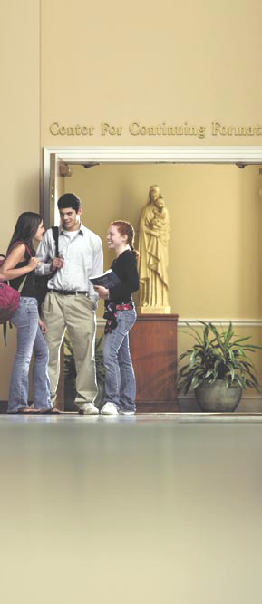  Throughout its history, St. Mary’s Seminary &  University has been a leader in theological education.  For more information, please contact Youth  Theological Studies at 410-864-4157 or visit our  Web site at www.stmarys.edu.  Throughout its history, St. Mary’s Seminary & University has been a leader in theological education. For more information, please contact Youth Theological Studies at 410-864-4157 or visit our website at www.stmarys.edu.  Youth Theological Studies |  | ST. MARY’S SEMINARY & UNIVERSITY  YOUTH  THEOLOGICAL STUDIES  Youth Theological Studies at St. Mary’s Seminary & University was established  to create opportunities for high school  students to study theology, engage in  dialogue, and deepen their understanding  of faith in a pluralistic society.  Founded in 1791, St. Mary’s Seminary  & University in Baltimore is the first  Catholic seminary established in the  United States. St. Mary’s is owned  and operated by the Sulpician  Fathers, a community of  diocesan priests dedicated  to the formation of priests.  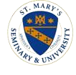  5400 Roland Avenue • Baltimore, Maryland 21210 410-864-4157 • youth@stmarys.edu www.stmarys.edu |  | YOUTH  THEOLOGICAL STUDIES  Higher education begins from within  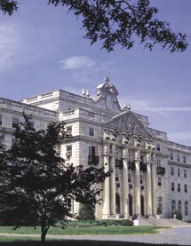  ST. MARY’S SEMINARY & UNIVERSITY
St. Mary’s Seminary & University  YOUTH  THEOLOGICAL STUDIES  Higher education begins from within.  Youth Theological Studies at St. Mary’s Seminary & University creates opportunities for high school students to study theology, engage in dialogue, and deepen their under-standing of faith in a pluralistic society. The Pinkard Scholars Program is the cornerstone of Youth Theological Studies at St. Mary’s. Those admitted to this challenging program explore their religious beliefs and questions at the college academic level. In the process, their understanding of faith is deepened and their appreciation of theology is rooted in careful reasoning.  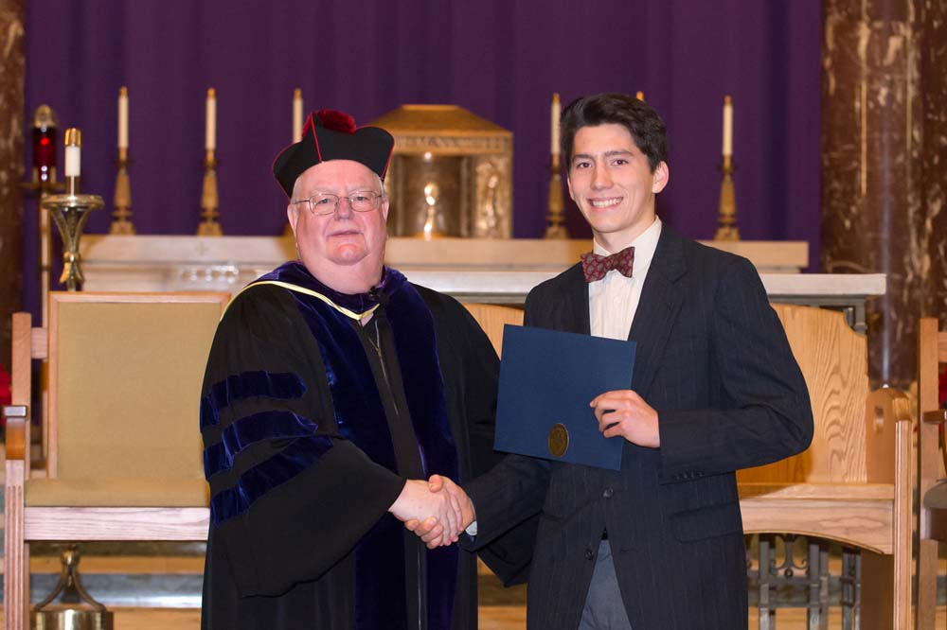  St. Mary’s Seminary in Roland Park is an ideal  setting for this high school experience. Founded in 1791, St. Mary’s is the first Catholic Seminary in the United States. Its Knott Library has the largest theological and biblical collection in the region. And, its magnificent Chapel and campus provide a superb environment for inquisitive young theologians.  A semester of Learning |  | 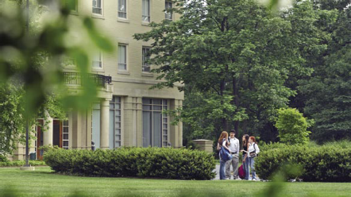  St. Mary’s Seminary & University’s Pinkard Scholars Program offers young people the unique advantage of earning three undergraduate credits in theology which may be applicable to their future college education. The full program includes a one-semester course covering a wide range of theological topics. Students read, analyze, and discuss classic texts in the Bible and in such authors as Aquinas, Ratzinger, Luther, Wright, Haugen, and others. Building on the notion of theology as “faith seeking understanding” Pinkard Scholars deepen their capacity to think and reason critically about perennial theological questions while in dialogue with critical cultural issues facing the contemporary world today.  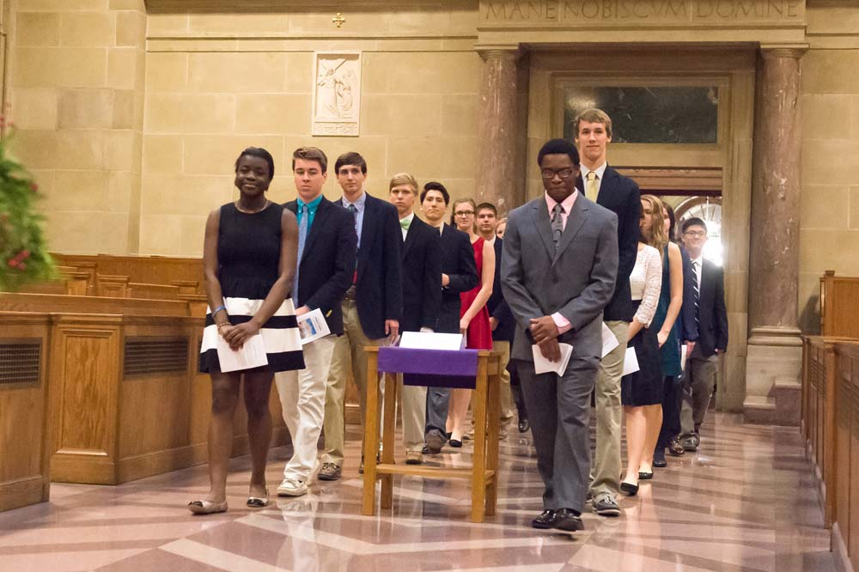  Religious Studies 235: Foundations for Dialogue: Theology and Culture increases students’ understanding of the foundational Christian doctrines and spiritual concepts which are needed for social, ecumenical, and interfaith dialogue that can begin to evolve a culture of peace in the midst of human suffering and systemic violence.  An exploration of Faith AND CULTURE |  | Candidates for the program are high school sophomores. The program will take place during fall of their junior year. They should have a proven capacity to work at the college level, demonstrate a curiosity about Christian theology, and have an openness to develop the necessary skill set for dialogue between theology and culture. Potential candidates are nominated by their high school principal, guidance counselor, religion or humanities department chair, or campus minister. Candidates may also be nominated by their churches or congregations.  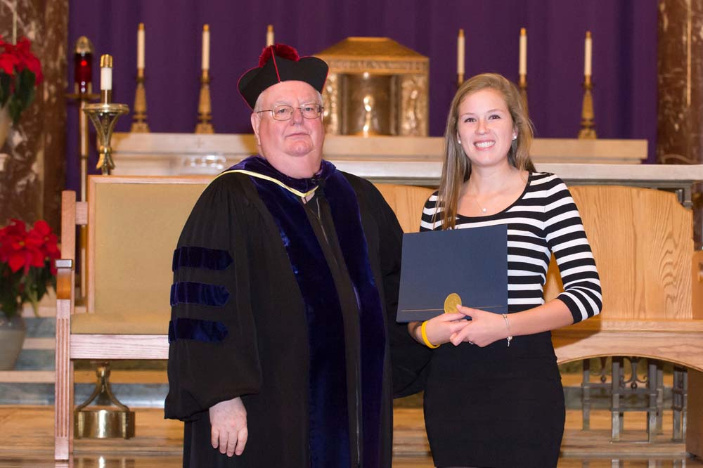  Pinkard Scholars pay partial tuition and fees. Students must provide their own transportation. A limited number of partial scholarships are available annually to cover costs.  For more information, please contact Youth Theological Studies at 410-864-4157 or visit our web site at www.stmarys.edu.  A Foundation for the Future

